Executive Summary

Company Name & Contact Information
Company A
1000 XXX Street, Union, NJ 07083
Founders: John Doe and Jane Doe
Email: XXX@XXX.com

Opportunity/Problem
A common problem many young people face is acne. One day you’re in the clear with blemish-free skin and the next morning you wake to your reflection with a new addition, a zit. Now imagine if there was a mirror that could tell you when you’re about to get a zit on your face and ways to prevent it. It would help prevent those pesky zits from popping up unsuspectingly, as well as help you come up with a skin care routine that really works. Insecurity stems from the way one views themselves based on societal standards: this can come from blemishes in one's appearance or simply from the reflection one portrays of themselves. Many times the root of insecurity begins when their appearance is not as perfect as displayed on all celebrities. Blemishes and acne cause sense of insecurity for young adults, as they are struggling with hormonal changes. Many try dozens of products to help alleviate the symptoms, but instead end up irritating their skin and causing permanent scarring.

Solution
Our company, Company A, wants people to feel confident in the skin they’re in. Our mirror detects when a blemish or pimple is occurring and shows you a list of problems to help cure the symptoms at the source. Company A combines modern technology with innovative sensors to help scan facial features and analyze exactly what is going on beneath the surface of their skin. After processing the information it detects and receives, the mirror then scans through the internet to come up with a variety of products that can help improve skin and acne conditions. Thus, allowing people to achieve clearer skin and get rid of insecurities stemming from how they view themselves from their reflection in the mirror. Our product will help consumers cut the root of the problem so they can start to appreciate their view in the mirror.

Target Market
Company A’s primary target market is middle-class women and men in the age of 18-30. Studies show that women are more likely than men to have acne past their teenage years. On the other hand, men are more likely to struggle to with acne for longer periods of times because they struggle to find solutions, due to feeling uncomfortable when it comes to going into beauty supply stores that offer the products they need. Company A allows both men and women to know the exact product, prices, and locations, giving them the ease of knowing exactly what to buy and where to buy it, whether it be online or in-stores.

Competition
In the technologically advanced mirror industry, our main competitor is HiMirror, a system that assesses skin condition and advises on skincare products. Mirrorvue Smart Touch Mirror and Perseus Mirror are also smart mirrors but they are mainly for showing information such as schedule, news and videos. Therefore, these two are indirect competitors.

Why Us?
We plan to give new customers a free shipment containing 10 sample sized facial products, based on what the mirror has gathered from their skin conditions, within three months of purchasing. This would be an incentive for customers to purchase our mirror, rather than our competitors. Another advantage is that we are in the target market and experience the sense of insecurity from facial blemishes. We can better understand our target market. Our team has much experience and many connections in the cosmetics industry. In addition, a team member has experience and connections in the IT hardware industry. We have the expertise and resources to take advantage of this market opportunity.

Forecast
Company A will not be profitable within the first year, because it takes time for market acceptance. In the first three years the projected revenue will be 312k, 620k, and 930k, respectively. We assume most of our expenses will come from manufacturing the hardware and software, related R&D and marketing.
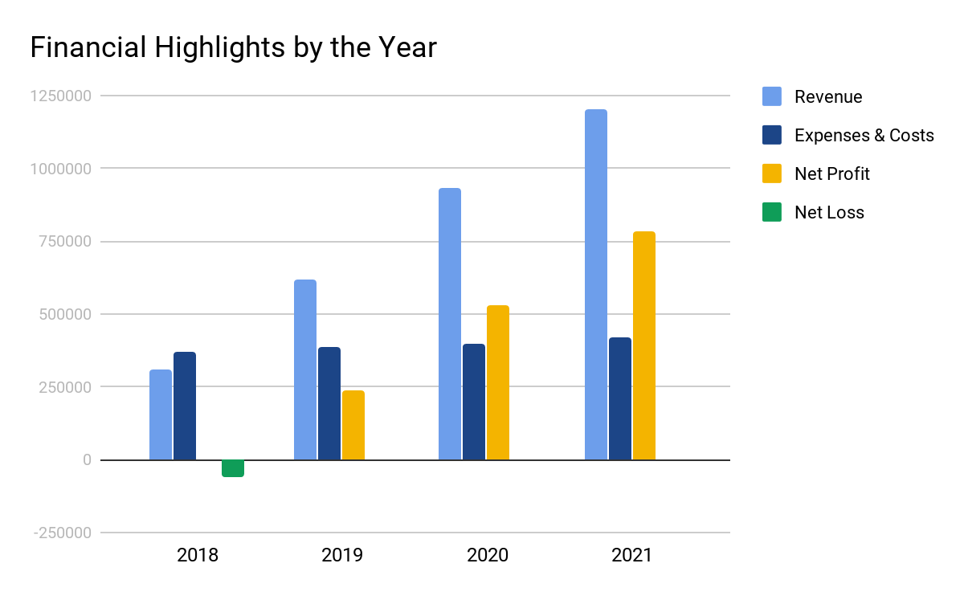

Financing Needed
Company A would need a total of $500,000 to start. Each of us will invest $100,000 of our own money bringing us to $300,000. Then we are looking to obtain $100,000 for funding through Kickstarter or Gofundme. Lastly, we are asking for the remaining $100,000 from investors and lenders. $100,000 will go towards supplies and materials, like software, hardware and glass cutting tools. $100,000 will go towards research and development. $50,000 towards partnering with certified dermatologists and $50,000 will go towards engineers and software developers. $15,000 will go towards the patent and license for our product. The mirror will be updated with more advanced technology and capabilities as time goes on. $100,000 will go towards marketing campaigns. $35,000 towards rent, office, and storage and $50,000 towards operations.

