- Company Name & Contact Information
- Company name and location:
Intellectual exchange community
Dormitory in Wenzhou-Kean University, 88 Daxue Rd, Ouhai, Wenzhou, Zhejiang Province, China 325060 (most business process is operated online).
- Personal information:
Chen Yingfangping, cheyingf@kean.edu, +86 137-5084-4073
- Opportunity
In modern society, there is no channel for university students to acquire various skills freely before entering the workplace. This gives our company an opportunity to establish a website for them, exchanging their intangible assets with others to gain some knowledge to realize their own development. Besides, during the process, they may find some kindred spirits.
- Solution
Our company provides an online website for our customers to display their talented skills and also search for other users who show the skills they have interest to learn. Also, in the start stage, we will focus on Wenzhou area.
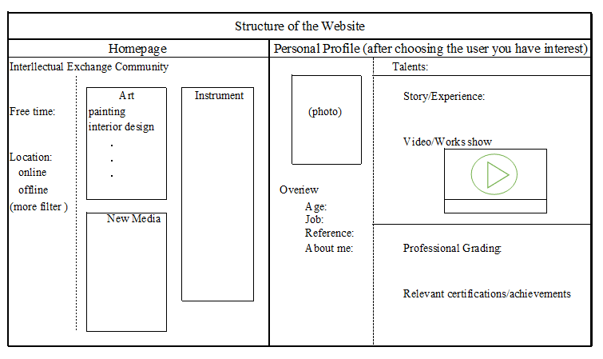
- Competition and Competitive Advantage
- Currently, Wenzhou Ganji website provides the sub-channels of “Skill exchange”, allowing users to learn talented skills through this channel, whereas some problems do exist. It doesn’t have the classification efficient enough to help users to find posts they are interested in and users can only exchange skills between two parties.
- Our company supplies level classification and responses for users to guarantee the quality of teaching and also find congenial study partners that suit them. We can help users achieve skill exchange between more than two parties. Our enterprise spirit is to claim significance of intelligent assets and appeal public to maximize the utilization of individual talents.
- Target Market
In the start stage, we focus the primary target market on university students In Wenzhou Chashan area, roughly 30,000 people.
The existence of this website helps college students participate in meaningful social activities and become versatility.
- Why Us?
The members of our executive producers are university students. We know the mentality of university students, and what they want to acquire through using this website. We have wide customer base (our classmates and school fellows). Therefore, we can find the defects of our service timely.
- Forecast
The original intention for our company is to establish a P2P platform for customers to learn the extensive skills. In this stage, our company might be in the red. The major income is from advertising revenue, roughly 10,000 RMB. However, our final goal is to establish a community model and credit rating system to substantiate intangible assets based on the quality of users’ intelligence. Also, our company will introduce an “intelligence currency,” which is a substitute with currency in circulation and could represent the quality rating of users’ intelligence. This platform will provide an opportunity for self-employed teachers to show themselves and be more competitive in the market. This trend will provide the customers more options in selecting diverse education. The intelligence currency would become another medium of exchange. Our company can use this funding to expand the scale of the platform. With more users joining in the platform, we could make profit in holding events and information resources sharing.
- Financing Needed

Establish the website | 5,000
Take in some self-employed class and traditional craftsmen to attract the first users | 7,000
Advertising fee on campus | 6,000
In total | 18,000
Crowd funding for the set-up capital: it would be a good chance to attract the first users.

